John White
1933 to 2025
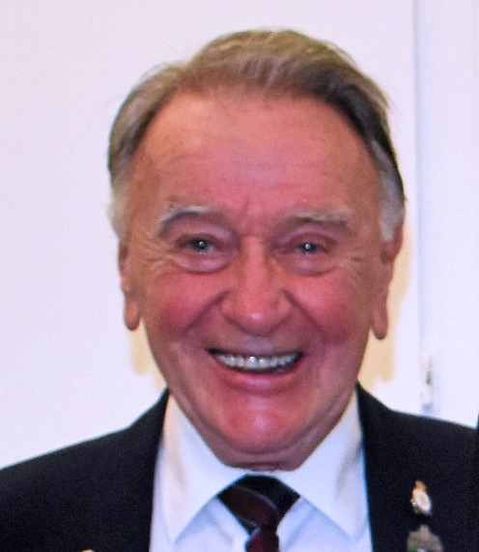 | Comrade John G. White was born in Glasgow Scotland and passed away July 18th 2025. John joined the Royal Corps of Signals a combat support arm of the British Army November 15, 1951 and served in the UK and Germany until November 15, 1953. After retiring from the Royal Signals, John worked in the John Brown Shipyards in Scotland and then emigrated to Canada in 1956 to join Ontario Hydro as a draftsman. John continued as a draftsman with several engineering firms in Canada until his final retirement from Petro Canada in Calgary in 1988.
John then moved to Sidney BC and discovered and joined ANAVETS Sidney Museum Unit 302 in 1991. During his extensive years as an Active member of Unit 302, John exceled in many ways through contributions of time and effort. He was the Unit’s Election Officer for many years, on the Taxation Committee, Member of the Year Committee, and By-Laws Committee. In addition, John volunteered his time and efforts as a team cook at Club picnics including setting up and tearing down of the event’s equipment, participated in Club Clean-ups, worked with the Club Executive House Chair assisting whenever and wherever he could, worked with the Mother’s Day team serving & helping in the galley and, attended meat draws. John had also been a team player in Darts in the Victoria Men’s Darts Association, Bocce Ball and Crib all at the Provincial Command competition level.
John White was an outstanding current member of Unit 302 having received his Association Long Service pins, Member of The Year in 2009 and, Certificate of Appreciation for his service to the Unit in that same year.
John then earned the prestigious recognition for his efforts becoming a Life member of the Army, Navy and Air Force Veterans Association in 2014.
John White Was decorated with The UK National Service Medal, Germany 1951 – 1953 and the Queens Royal Medal 1953 as well-earned military awards.

